Batch: B1 Roll No.: 16010122134

Experiment No. 7

TITLE : To perform VLab on NLP

AIM: Vlab on NLP
Expected OUTCOME of Experiment:
CO5: Apply data analytics in the field of Health care.
_____________________________________________________________________
Books/ Journals/ Websites referred:

Students have to list.
_____________________________________________________________________
Pre Lab/ Prior Concepts:

Students should have a basic understanding of word analysis.

Procedure:
Vlab Name: Computer Science and Engineering -Natural Language Processing- Word Generation
Vlab Link: https://nlp-iiith.vlabs.ac.in/exp/morphology/

Output:
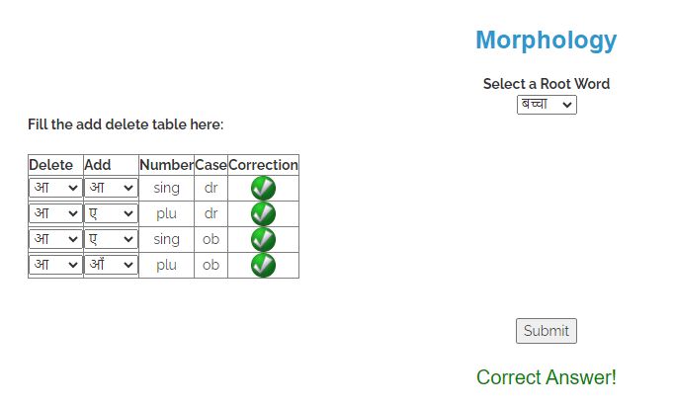
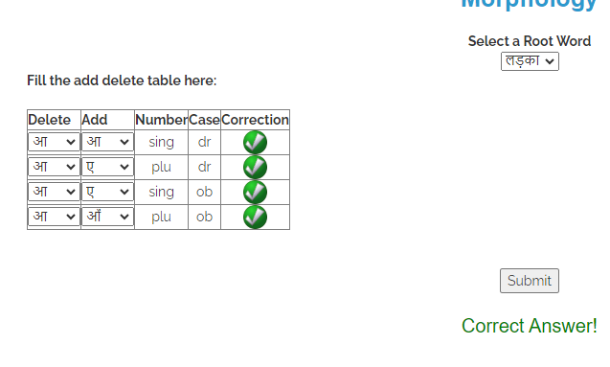
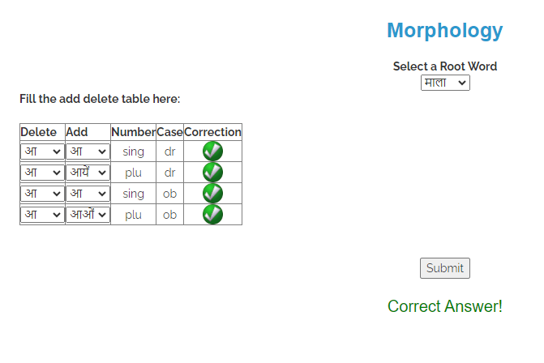
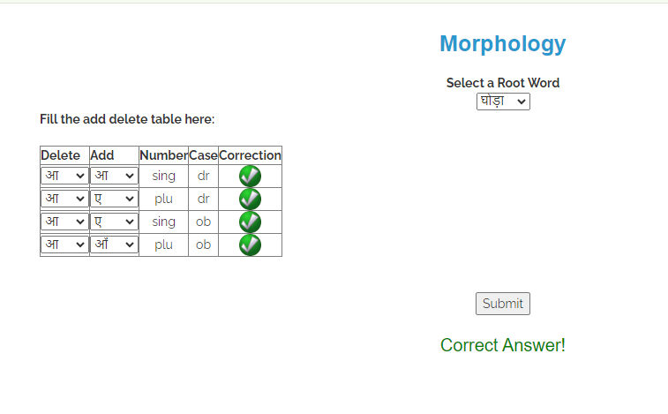
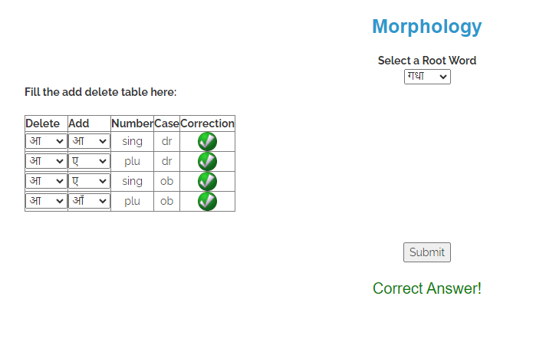
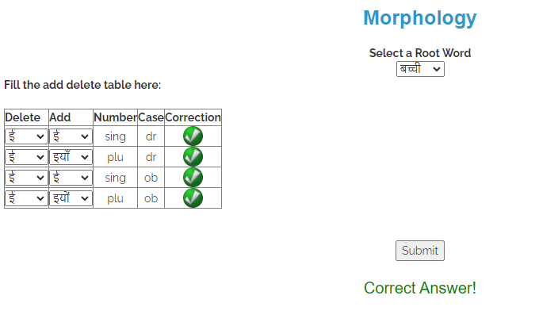
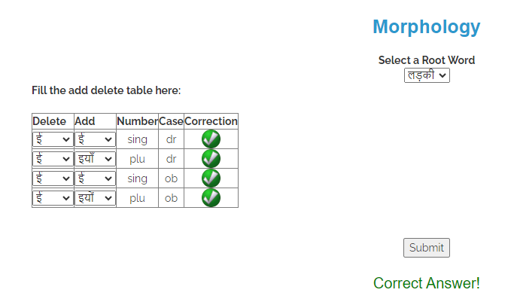
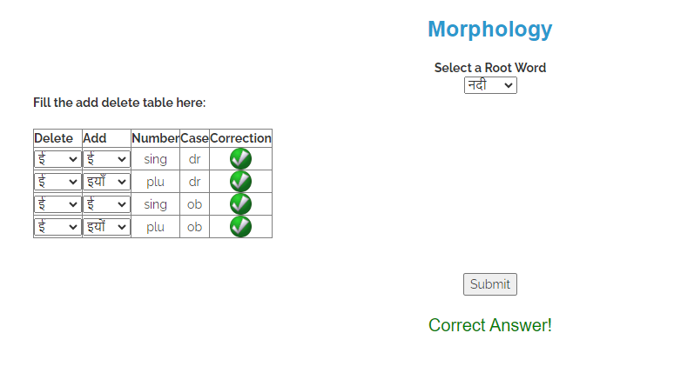

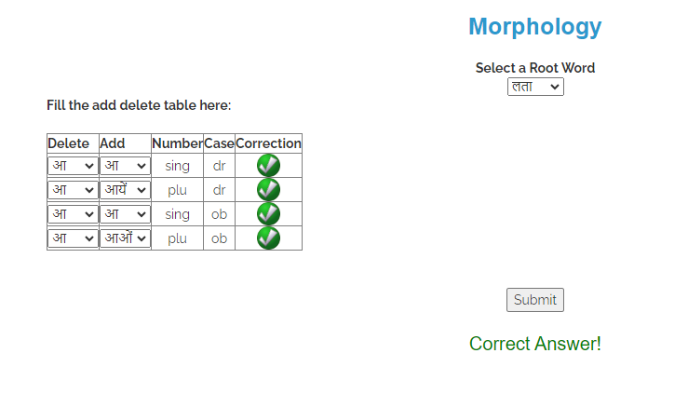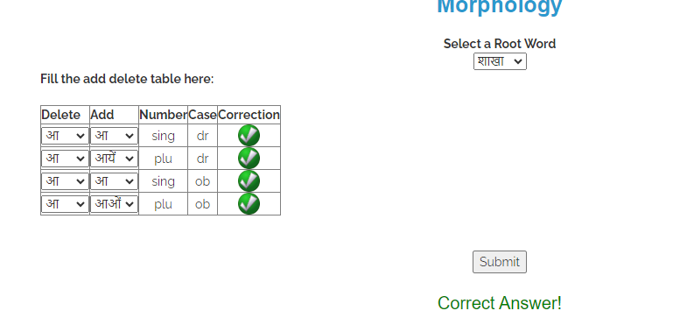
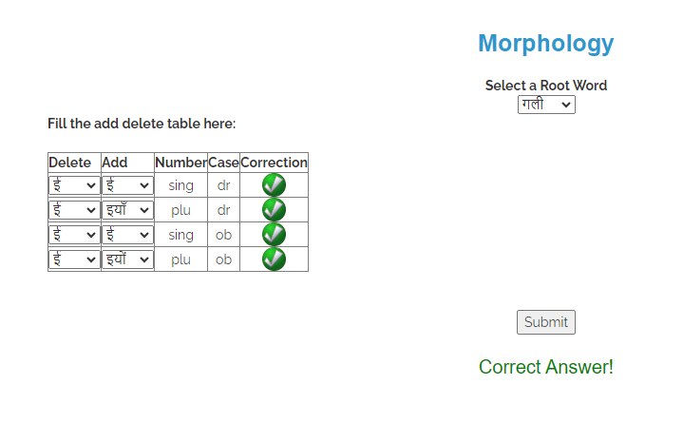

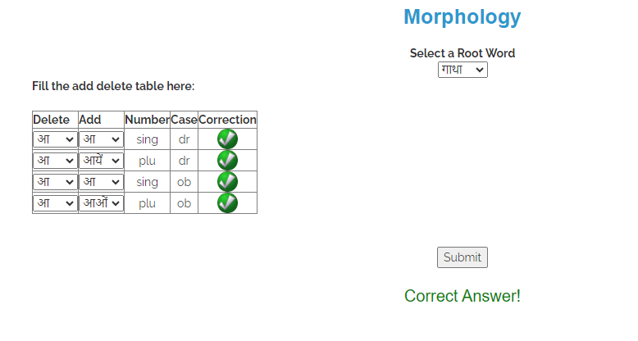

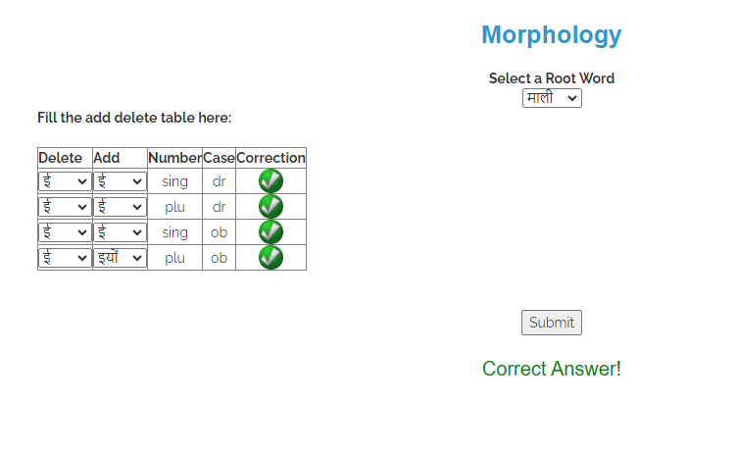

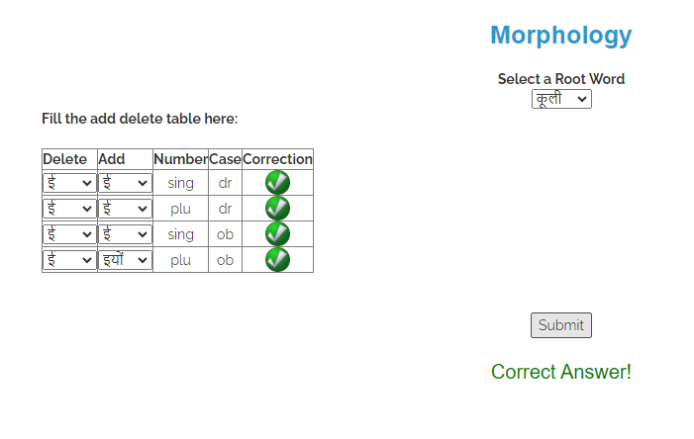

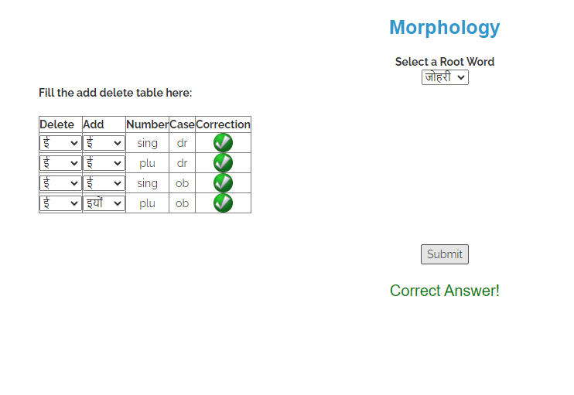

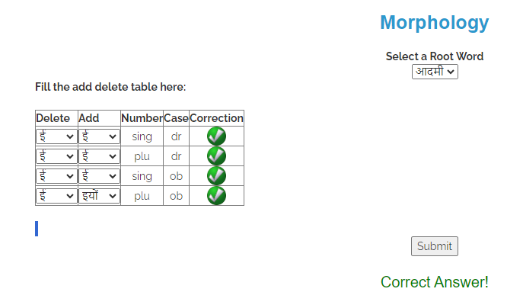

Implementation details:
We did the VLAB simulation and learnt the concept of NPL.

Date: 17/10/24 Signature of faculty in-charge

Post Lab Descriptive Questions:

Q.1 Explain various applications of NLP.
Ans : Applications of NLP

1. Sentiment Analysis: Gauging public opinion from social media and reviews.
2. Chatbots: Powering virtual assistants for customer service and personal use.
3. Machine Translation: Automatically translating text between languages.
4. Text Summarization: Creating concise summaries of long documents.
5. Speech Recognition: Converting spoken language into text for various applications.
6. Information Retrieval: Enhancing search engines and query understanding.
7. Named Entity Recognition: Identifying key entities in text for data extraction.
8. Grammar and Spell Checking: Improving writing quality through automated suggestions.
9. Content Recommendation: Suggesting relevant content based on user behavior.
10. Document Classification: Organizing documents for easier access and management.

Q.2 What is the significance of Natural Language Processing (NLP) in modern technology, and how does it impact various industries?

Ans : Significance of NLP

NLP is crucial in modern technology as it enables machines to understand and interact with human language, enhancing user experience and accessibility. It impacts industries by:

- Customer Service: Automating interactions and improving response times.
- Healthcare: Analyzing patient data and medical literature for insights.
- Finance: Streamlining data analysis and fraud detection through text mining.
- Marketing: Personalizing customer outreach and sentiment tracking.
- Education: Enhancing learning tools and resources through intelligent tutoring systems.

Overall, NLP transforms how businesses operate, improving efficiency and decision-making across sectors.

